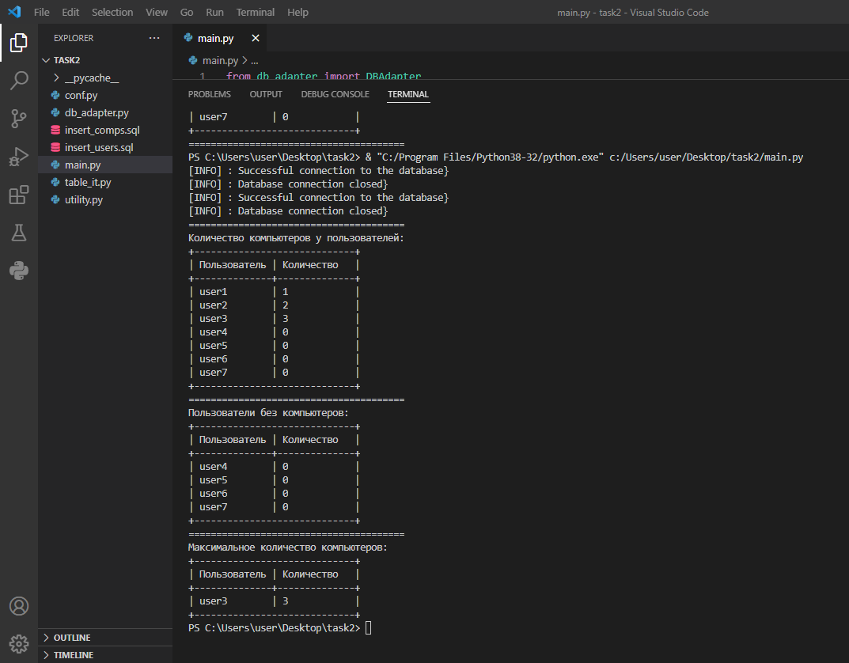

PS C:\Users\user\Desktop\task2> & "C:/Program Files/Python38-32/python.exe" c:/Users/user/Desktop/task2/main.py

[INFO] : Successful connection to the database}

[INFO] : Database connection closed}

[INFO] : Successful connection to the database}

[INFO] : Database connection closed}

=======================================

Количество компьютеров у пользователей:

+-----------------------------+

| Пользователь | Количество |

+--------------+--------------+

| user1 | 1 |

| user2 | 2 |

| user3 | 3 |

| user4 | 0 |

| user5 | 0 |

| user6 | 0 |

| user7 | 0 |

+-----------------------------+

=======================================

Пользователи без компьютеров:

+-----------------------------+

| Пользователь | Количество |

+--------------+--------------+

| user4 | 0 |

| user5 | 0 |

| user6 | 0 |

| user7 | 0 |

+-----------------------------+

=======================================

Максимальное количество компьютеров:

+-----------------------------+

| Пользователь | Количество |

+--------------+--------------+

| user3 | 3 |

+-----------------------------+